**What were the consequences of the Second Intifada for Palestine-Israel?**

**Lesson 13**

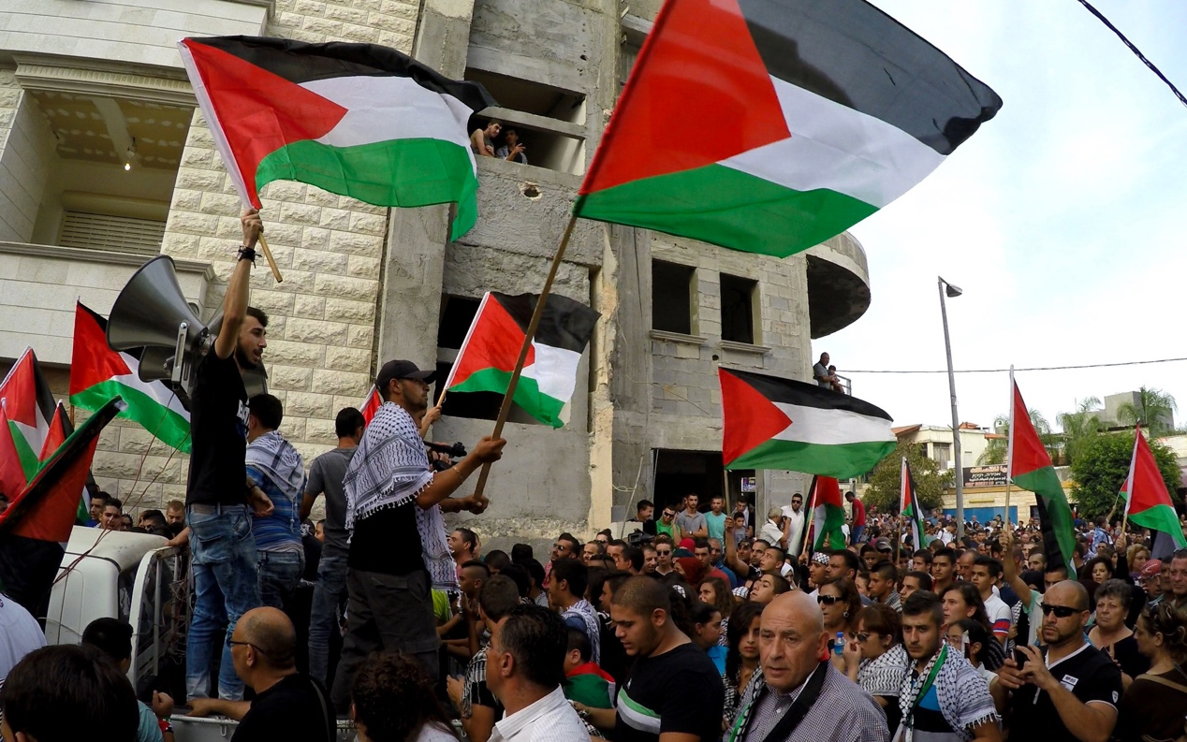

**By the end of this lesson, you should be able to:**

Describe what the Second Intifada was

Explain the causes of the Second Intifada

Discuss the consequences of the Second Intifada

**Keywords**

Al-Aqsa Mosque

Ariel Sharon

2000 Camp David Summit

Second Intifada, 2000-2005

**Knowledge check!**

1)What is the keffiyeh?

2)What were the Oslo Accords?

3)Were they successful?

4)What was the Sabra and Shatila massacre of 1982?

**2000 Camp David Summit**

Camp David is the country retreat of the US President. At Camp David in 1978, US President Jimmy Carter brokered an agreement between Egyptian President Anwar Sadat and Israeli Prime Minister Menachem Begin. In 2000, US President Bill Clinton invited Yasser Arafat (Head of the PLO and now Chairman of the Palestinian Authority) and Ehud Barak (Israeli Prime Minister) to Camp David, in the hope of once again brokering a deal between two opposed leaders. Unfortunately, **no agreement was reached**. This is important context for understanding the outbreak of the Second Intifada in 2000

**The Second Intifada (2000-2005)**

*Another massive uprising of Palestinians against Israel, triggered by the failure of the Oslo Accords and the 2000 Camp David Summit*

Also known as the *Al-Aqsa Intifada*

**The significance of Jerusalem: Recap**

Jerusalem, particularly the Old City including the Al-Aqsa Mosque area, is important to Jews, Christians and Muslims for different reasons

For Jews, all of creation began in Jerusalem. The Western Wall in the Old City of Jerusalem is the **holiest place where Jews can pray**

For Christians, Jerusalem is where **Jesus preached, celebrated his Last Supper, died by crucifixion, and was resurrected by God**

For Muslims, Jerusalem is from where the prophet Muhammad **ascended to heaven**

**Al-Aqsa Mosque**

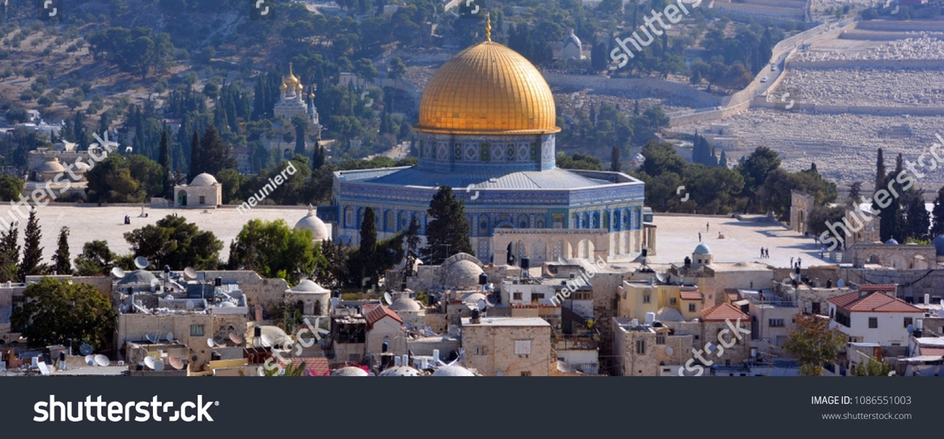

Over 90% of Palestinians are Muslim. Al-Aqsa Mosque is the holiest site in Jerusalem for Muslims. Located in the Old City of Jerusalem, it is the third holiest site in Islam, after Mecca and Medina. Al-Aqsa Mosque was the first Qiblah (direction for prayer) and the **second mosque ever built**

**Why was there another Intifada?**

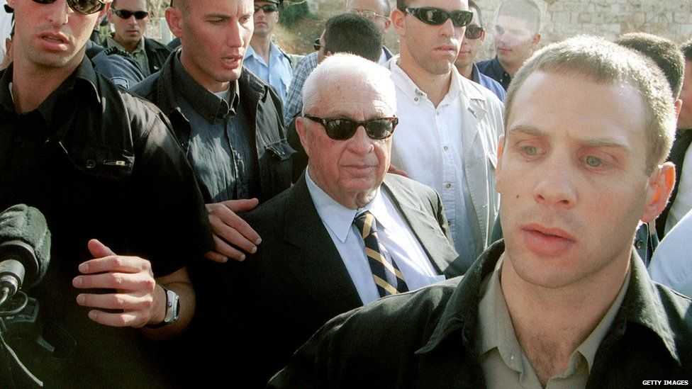

Long-term causes:

-The ongoing question of **land**: Israel still occupied the West Bank, Gaza and East Jerusalem

-The **continued construction of illegal Israeli settlements**: Israel was still demolishing Palestinian homes and allowing settlements to be built on Palestinian land, despite many UN Security Council Resolutions condemning this

-The ongoing **Palestinian refugee crisis**: by 2000 there were 5 million Palestinian refugees in Israel and the occupied Palestinian territories

-Continued disagreement about **Jerusalem**: Israel had now occupied East Jerusalem since 1967. Who should have access to the Al-Aqsa Mosque area in the Old City? For Muslims, this is the third holiest site in Islam. For Jews, this is where all of creation began

Short-term causes:

-The Oslo Accords had **failed**, and so had the Camp David Summit in July 2000

-16th-18th September 2000 was the anniversary of the **Sabra and Shatila massacre**. It had recently been ruled that Israeli Prime Ministerial candidate Ariel Sharon bore some personal responsibility for what had happened

Trigger causes:

-On 28th September 2000, **Israeli Prime Ministerial candidate Ariel Sharon visited the Al-Aqsa Mosque area.** Many Palestinians saw this as antagonistic

**UN Security Council Resolutions**

Between 1967 and 2000, numerous UN Security Council Resolutions condemned the construction of illegal Israeli settlements on Palestinian land:

Resolution 237 (1967)

Resolution 252 (1968)

Resolution 267 (1969)

Resolution 271 (1969)

Resolution 298 (1971)

Resolution 465 (1980)

**Israeli Prime Ministers in the 1990s and 2000s**

1992-1995: **Yitzhak Rabin** (Rabin was assassinated by an extremist in 1995 for his role in the Oslo Accords)

1996: **Shimon Peres**

1996-1999: **Benjamin Netanyahu**

1999-2001: **Ehud Barak** (Barak had joined Yasser Arafat and Bill Clinton for the 2000 Camp David Summit, which ultimately failed)

2001-2006: **Ariel Sharon** (Sharon visited the Al-Aqsa Mosque area in September 2000, which sparked the Second Intifada)

**Activity**

Create a spider diagram explaining the long-term, short-term and trigger causes of the Second Intifada:

Extension question: Are any of the causes linked? Draw a line between the causes that are linked and write a sentence underneath explaining the link between them

**Question**

What was the most important cause of the Second Intifada? Write a paragraph to explain your answer

**Timeline of the Second Intifada**

-Bill Clinton, Yasser Arafat and Ehud Barak (Israeli Prime Minister) **fail to reach an agreement** at the Camp David Summit, July 2000

-Palestinians commemorate the Sabra and Shatila massacre on 18th September 2000. It had recently been ruled that Ariel Sharon bore some **personal responsibility** for the massacre

-Israeli Prime Ministerial candidate Ariel Sharon visits the Al-Aqsa Mosque compound on 28th September 2000. Sharon doesn’t enter Al-Aqsa Mosque itself, but Palestinians view this as **antagonistic, and violence breaks out**. Palestinians throw stones and the IDF fire rubber bullets and tear gas

-In the final days of September and the first days of October 2000, **violence spreads** across East Jerusalem, the West Bank and Gaza

-The Taba Summit takes place between Arafat and Barak in Taba, Egypt in January 2001. They fail to reach an agreement and the **violence between Palestinians and Israelis continues**

-March 2002 sees many **suicide bombings** by Palestinians in Israel: around 130 Israelis are killed

**-Operation Defensive Shield** by Israel takes place in the West Bank between March and May 2002. 500 Palestinians are killed and 5000 Palestinians are arrested

**-The Road Map for Peace** (a plan to solve the Palestine-Israel issue) is introduced in 2002

-On 11th November 2004, Yasser Arafat **dies** in Paris. In early 2005, **Mahmoud Abbas** is elected President of the Palestinian Authority

-Sharon and Abbas sign a mutual truce at the Sharm el-Sheikh Summit on **8th February 2005**

-But did the violence end in February 2005? No. Attacks continued on both sides. We’ll come back to this in Lesson 14, including the role of an organisation called *Hamas*

On 29th October 2000, a photojournalist took this photo of 14 year old **Faris Odeh** throwing a stone at an IDF tank. When throwing stones ten days later, Faris was shot in the neck by IDF soldiers and died

On 30th September 2000, 12 year old Palestinian **Muhammad al-Durrah** was killed by Israeli soldiers whilst hiding behind his father. This tragic image was shared across the world

**Palestinian victims of the Second Intifada**

Killed: 3,334

Injured: 52,000+

Students injured: 4,090

Schools attacked: 850

Palestinian journalists killed: 12

Overall damage to Palestinian economy: $10bn

**Consequences**

Overall, over **3000 Palestinians and 1000 Israelis** lost their lives as a consequence of the Second Intifada

Did the violence end? As we have already seen, **the violence continued**. We’ll return to this in a future lesson

A big consequence of the Second Intifada was that Israel started building what is now known as the **Apartheid Wall** in 2002. We will also return to this in a future lesson, but this is a wall that runs roughly along the border between Israel and the occupied West Bank. Israel has been criticised for using the Wall to take more Palestinian land

After the Second Intifada, Israeli settlement building continued apace, despite the multiple UN Security Council Resolutions condemning the building of settlements

Both Israelis and Palestinians felt increasingly discouraged about the idea of a **“two-state solution”** to the problem – how could a Palestinian state ever function? Would Israel ever let it? And would Israel ever be safe?

**Question**

What was the most important consequence of the Second Intifada? Was this different for Palestinians vs. Israelis? Why? Make a note of this in your book